SECRO DRAFT INVESTMENT MEMO

To: | - SeaAhead Blue Angels group
Deal Team: | - Peter Russotti, Luke Sawitsky, Yusuke Matsui, Kris Sethi
Date: | - July 2022

Company Profile
Company: Secro | Investment Round: Seed
Industry: Maritime and Global Trade | Investment Amount: $3MM
Stage: Pre-revenue | Security Type: Equity
CEO: Michele Sanricca | SeaAhead Mandate Fit: Good
Deal Source: Blue Angels | SeaAhead Synergy:

Overview | Secro is a New York based technology company that seeks to replace the extremely antiquated, paper-based approach to document creation and management within the maritime space of global trade. Their goal is to become the industry’s main platform first for Electronic Bills of Lading (eBL) and other digitized trade documents, followed soon after by providing supply chain finance solutions for companies engaging in international trade of commodities and containerized goods.  Their team has created an extremely intuitive and user-friendly online product that works in a similar a similar way to DocuSign, where users can easily invite disparate parties within a trade onto the platform in order to issue, negotiate, transfer, deliver, and surrender BLs in a much more efficient and secure manner. This expediency means quicker payments and less line of credit financing costs for their customers.  Secro’s fully collaborative SaaS platform will allow users to control these multiple workflows in one place, increasing efficiency and reducing the risk of errors or potential fraud. In addition, documents can be transformed into smart contracts, whose prose can then become an actionable sequence of activities executed and validated by counterparties; all of which is then stored on a blockchain as an immutable record for any potential future claims or legal action.  Once they have achieved traction with their documents platform and have accumulated a substantial amount of client information, they plan on leveraging that financial performance data to offer better rates on lines of credit for mid-size importing companies that operate in emerging markets where obtaining letters of credit is more challenging and/or costly.  Eventually they intend to branch out into offering a full range of services to complete the platform, Legal Services, Treasury and Trade Insurance, etc, to increase stickiness and the overall utility for their clients.  See below a helpful graphic of where Secro sits in the trade chain.

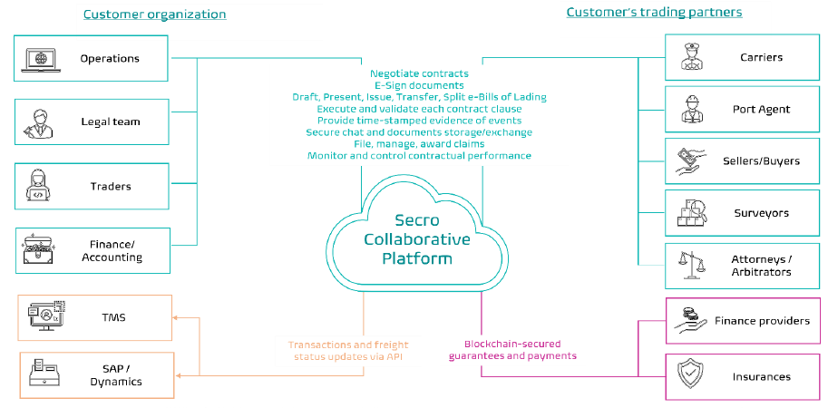

Market & Traction | - eBL and digitized trade documents at first within the bulk commodity space, ie oil traders and dry bulk companies.  - eBLs for container lines will come next once they establish traction.  - Their GTM will target midsize commodity players, first in developed countries, followed by mid-size companies in emerging markets and then larger trading houses like Vitol, BHP, etc.  - They currently have one customer (Nitron) ready to join the platform in Oct 2022 when it will be ready to go live.

Financials | - Financial projections provided by the company below

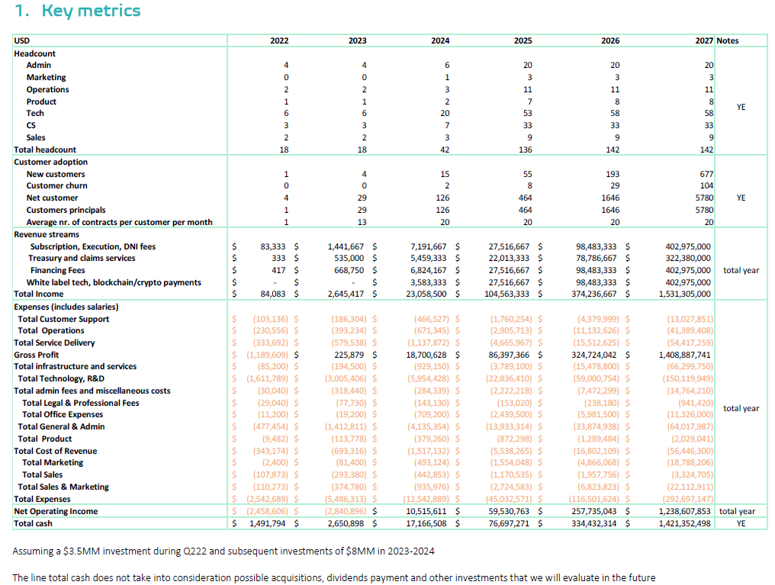

Team | - Strong team with extremely relevant backgrounds in the technology, maritime, and legal worlds.  - Michele Sanricca – CEO and Co-founder – Ex MSC, AWS and HBS  - Luke Zadkovich – Board Director and Co-Founder – International Trade Attorney based out of New York  - Piotr Cihocki – Head of Compliance – 22 years if shipowning experience

Competition | - There are several other competitors out there, but no one doing exactly what Secro plans to offer.  - EssDocs and Bolero (legacy eBL players) have been around for many years, yet have been unable to crack the eBL adoption problem.  - For the competitors who are focusing on container trades, it is very difficult for them to adapt their technology to commodity trades.  - From a payments/financial point of view, Komgo appears to a main competitor since they have the backing and investments of major banks and Oil traders.  - See below comparison table provided my Secro

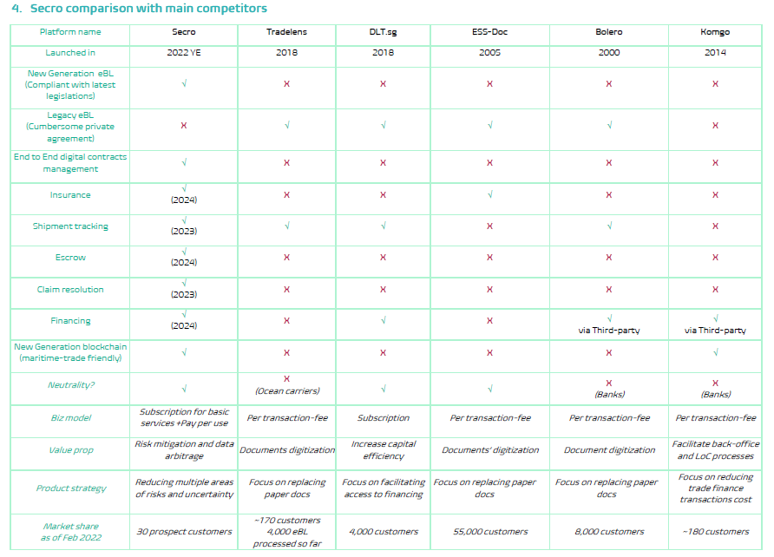

IP/Moat | - They are applying for a Process Patent for the end-to-end workflow of their “Collaborative Platform” – we need to better understand if this at all defensible or valuable.  - It seems that their main differentiator is the fact that they have a first mover advantage in creating a “force of law” platform (as opposed to a contract-based platform) and that they will provide a suite of services to the market.  - Our takeaway is that while the first mover, and UX, advantage is real and meaningful, the suite of services aspect may not be that influential.

Round Details | - Seed Round, raising $3MM on a $15MM pre money valuation  - They are currently in talks we a few VCs and larger strategics, and have apparently received a few term sheets already.  - Potential Exits: They want to IPO at some point, but we also could see a potential merger or acquisition by a tech company that has more complimentary services, like Komgo for example.

Strengths | - Large addressable market where currently the eBL penetration remains at around 1.5% of all BLs issued globally. Significant room for growth.  - The maritime industry has been waiting a long time for trade document digitization and we may now be at the moment of take off.  - Secro is addressing a true pain point for customers with their eBL solution.  - Easy to sign up to the platform, no lengthy contracts or complicated onboarding process. UX is intuitive and strong.  - Platform is online based so apparently no need for full IT integration with each new customer (but see below).  - Strong team with relevant experience in maritime, tech and legal spaces.  - Capital light model should allow them to scale revenue quickly without much follow-on investment. That said, we envision them raising at least one more round.

Concerns & Open Questions | - Will the banks be as accepting of using Secro’s platform as they claim?  - Will they really be able to build out the supply chain finance side of this? Will they be able to provide cheaper financing than banks? Maybe in the dry bulk space, but in the oil trades it seems unlikely.  - Their pricing strategy seems to be fairly expensive. How will potential clients respond to the Subcription + Pay-Per-Use model?  - Is the IT integration for each customer really as simple as they claim?  - How long will sales cycles be? The commitment to use the platform appears to be more significant than they claim.

Risks &Mitigants | - Risk: An antiquated industry is not ready for change  - Mitigant: There has been a recent development in the legality of eBLs coming out of Singapore that affords eBLs legal parity to paper BLs. A similar law in the UK is expected to pass within the next six months. Also, given the recent issues within the supply chain space during covid, there has been a greater push to begin initiatives to increase efficiency in global trade, especially within the container sector.  - Risk: This new legislation around eBL parity in international trade will also benefit the existing legacy eBL providers.  - Mitigant: Secro’s platform and functionality was built with this new framework in mind from the ground up. If other companies want to offer the same services, they will have to substantially rebuild their IT architecture, which will take time and essentially eliminate any head start they might have had.  - Risk: Many disparate parties in international trade make large scale adoption challenging.  - Mitigant: New users can sign up extremely quickly (existing users simply send a hyperlink to a new party to sign up), there are no contracts that need to be signed before becoming a user, and Secro’s KYC process will take under an hour. If need be, at any point in a trade the eBLs can be changed to paper BLs very easily. Additionally, Secro will soon have approval to operate from the International Group of P&I Clubs, which will give all shipowners confidence in using their platform.  - Risk: They will not be able to provide cheaper financing than legacy lenders  - Mitigant:???  - Risk:  - Mitigant:

